# HOME ALIGNED SERVICES

## A PROJECT REPORT

***Submitted by***

**PRADEEP RAM V (2116210701188)**

**PRAVEEN M (2116210701193)**

**PAVITHIREN D S (2116210701187)**

***in partial fulfillment for the award of the degree of***

**BACHELOR OF ENGINEERING**

***in***

## COMPUTER SCIENCE AND ENGINEERING



**RAJALAKSHMI ENGINEERING COLLEGE**

**ANNA UNIVERSITY, CHENNAI**

**MAY 2024**

# RAJALAKSHMI ENGINEERING COLLEGE, CHENNAI

**BONAFIDE CERTIFICATE**

Certified that this Thesis titled **“EXPENSE TRACKER APPLICATION”** is the bonafide work of “**PRADEEP RAM V (210701188), PRAVEEN M (210701193), PAVITHIREN (210701187)”** who carried out the work under my supervision. Certified further that to the best of my knowledge the work reported herein does not form part of any other thesis or dissertation on the basis of which a degree or award was conferred on an earlier occasion on this or any other candidate.

## SIGNATURE

Mrs. Ananthi S, M.E.,

## SUPERVISOR

Assistant Professor

Department of Computer Science and Engineering Rajalakshmi Engineering College

Chennai - 602 105

Submitted to Project Viva-Voce Examination held on **_**

**Internal Examiner External Examine**r

**ABSTRACT**

In an era characterized by interconnectedness and digital innovation, the Home Aligned Service App emerges as a transformative solution catering to the evolving needs of modern homeowners. This innovative mobile application seamlessly integrates a multitude of essential home services, ranging from security and maintenance to shopping and entertainment, into a unified platform. Leveraging the power of FlutterFlow for rapid development and intuitive design, the app prioritizes user experience and convenience.

Key features include comprehensive home automation capabilities, allowing users to remotely monitor and control devices, enhance security protocols, and schedule maintenance tasks effortlessly. Furthermore, personalized recommendations powered by machine learning algorithms anticipate user preferences, while robust privacy and security measures ensure the

confidentiality of sensitive data.

Through an intuitive interface, the Home Aligned Service App empowers users to streamline their daily routines, enhance efficiency, and elevate their overall quality of life. By embracing technological advancements and fostering seamless integration with existing smart home ecosystems, this app represents a paradigm shift in home management, marking a new chapter in the journey towards a connected and harmonious living environment.

**INTRODUCTION**

**1.1 DOMAIN INTRODUCTION**

In today's dynamic job market, the need for efficient employment platforms is paramount. This abstract introduces a Home Aligned Services Application, designed to bridge the gap between job seekers and employers in a streamlined manner. The application aims to offer a user-friendly interface with robust functionality to cater to the needs of both parties. The application provides a seamless experience for users, allowing them to easily navigate through job listings, profiles, and application processes.Through advanced algorithms, the application offers personalized job recommendations based on user preferences, skills, and location.Users receive instant notifications about new job postings, interview invitations, and application status updates, ensuring timely interactions and responses.The application facilitates direct communication between job seekers and employers, fostering transparent and effective interactions. By leveraging modern technologies and user-centric design principles, the Home Aligned Services Application aims to revolutionize the job search process, making it more accessible, efficient, and rewarding for both job seekers and employers alike.

**1.2 PROJECT INTRODUCTION**

The Home Aligned Services Application represents a culmination of extensive research, user feedback, and technological expertise aimed at addressing the pain points prevalent in contemporary job markets. Leveraging cutting-edge technologies such as machine learning, real-time communication, and data analytics, our application offers a comprehensive suite of features tailored to meet the diverse needs of today's workforce.At its core, the Home Aligned services Application is built upon the principle of simplicity and efficiency. Through an intuitive user interface, job seekers can effortlessly browse through a curated list of job opportunities, filter results based on their preferences, and submit applications with ease. Meanwhile, employers benefit from a streamlined recruitment process, gaining access to a pool of qualified candidates and robust communication tools to facilitate seamless interactions.In this current world, where everything is being digitalised, this app serves to bridge the gap between the workers who do small jobs and the job seekers who is mostly the home makers, as it is difficult to find them because there is no job portal platform for these kind of jobs.

**1.3 PROJECT OBJECTIVE**

The main objective of the Smart Room Power Saver using IoT project includes the design, development, and implementation of a system that optimizes energy consumption in a room using IoT technology .

⮚ Software Development: Developing the software infrastructure for data collection, transmission, and visualization, including firmware for the Wi-Fi module and the app interface.

⮚ Testing: Software testing tests seamless functionality and conducting rigorous testing to validate accuracy and reliability of energy 1011 consumption measurements.

⮚ User Interface Design: Designing an intuitive and user-friendly interface provide insights to users.

⮚ Documentation and Training: Providing comprehensive documentation and training materials to guide users through the setup, operation, and maintenance of the system.

⮚ Scalability and Future Enhancements: Designing the system with scalability in mind to accommodate additional sensors and appliances in the future. Additionally, laying the groundwork for future enhancements, such as the integration of Machine Learning algorithms for predictive analysis.

⮚ Deployment and Support: Deploying the system in real-world environments and providing ongoing support to users for troubleshooting and optimization.

**SYSTEM DESIGN**

**2.1 SYSTEM ARCHITECTURE DESIGN:**

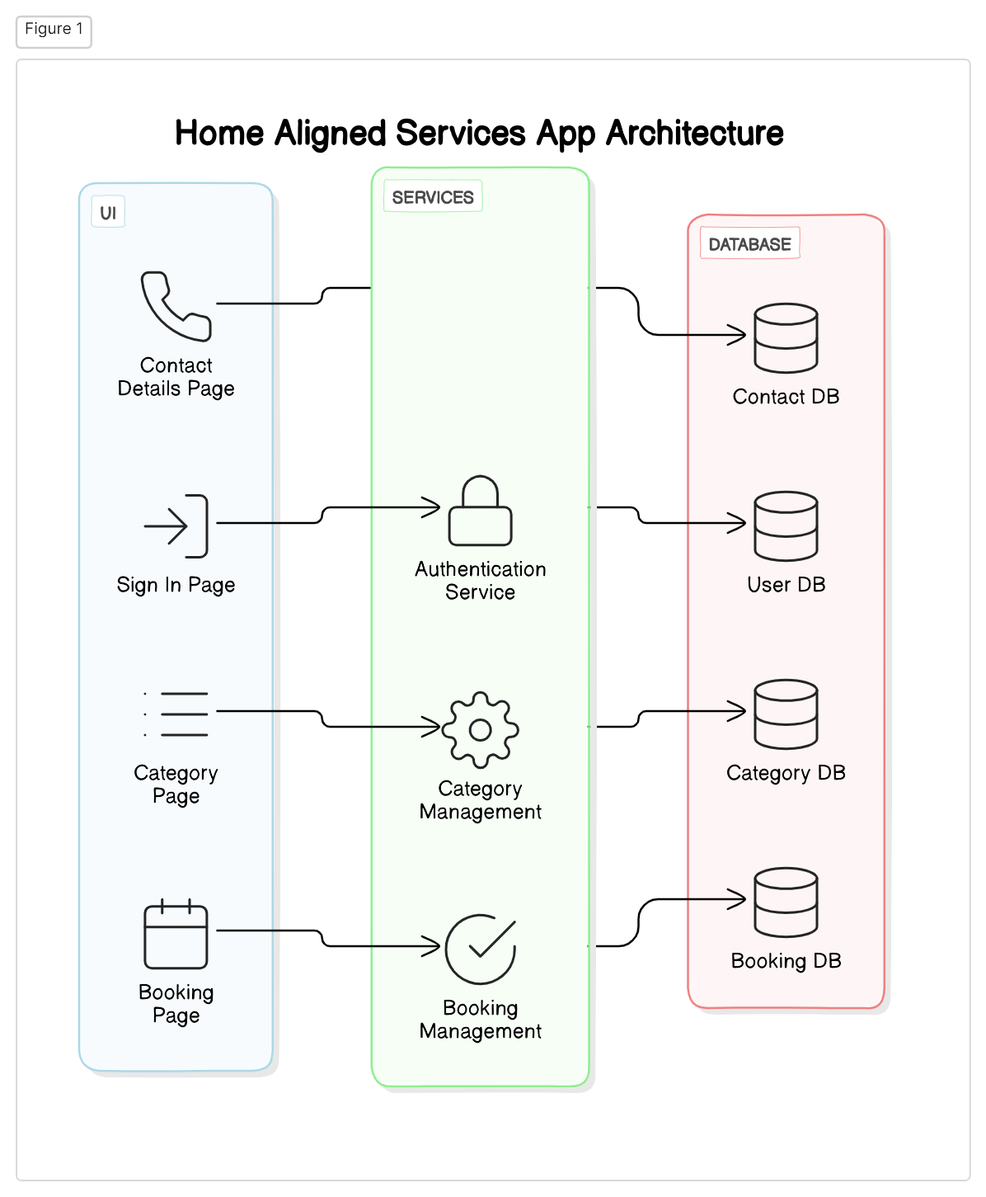

Overall, the architecture structure of the Home Aligned Services app is designed to see about the workers in particular location , category wise like laundry, cleaning, repair and details about that particular individual and cost of them for hour wise.

**2.2 SOFTWARE REQUIREMENTS**

* Android Studio (latest version)
* Kotlin programming language
* SQLite Database or Room Persistence Library for data storage
* Git for version control

**2.3 HARDWARE REQUIREMENTS**

* Android device or emulator for testing
* Internet Connectivity
* Server Infrastructure (Backend)
* Display Devices

**PROJECT DESCRIPTION**

**3.1 IMPLEMENTATION**

1. User Sample Selection:

Select a representative sample of users who have installed and used the Home Aligned Services APK. Ensure diversity in terms of demographics, geographic location, and usage frequency.

2. Experimental Variables:

Independent Variable: Use of the Home Aligned Services APK.

Dependent Variables: Various metrics related to user experience and service quality (e.g., response time, service completion rate, user satisfaction).

3. Experimental Procedure:

Divide the selected users into two groups: experimental group (users who will use the Home Aligned Services APK) and control group (users who will not use the APK). Ensure that both groups have similar characteristics to minimize bias. Instruct the experimental group to use the APK to request home services as needed during the experiment period. Monitor and record various metrics for both groups over a specified period (e.g., one month).

4. Data Analysis:

Analyze the collected data to compare the performance of the experimental group (APK users) with the control group (non-users). Use statistical methods to identify any significant differences between the groups in terms of response time, service completion rate, user satisfaction, etc. Interpret the results to draw conclusions about the effectiveness and impact of the Home Aligned Services APK on user experience and service quality.

**CONCLUSION AND FUTURE ENHANCEMENTS**

**5.1 CONCLUSION**

The Home Aligned Services would depend on the analysis of various factors such as user feedback, performance metrics, and overall effectiveness of the application.The Home Aligned Services demonstrates promise as a convenient platform for accessing a variety of home services including plumbing, maid services, and electrical assistance. User reviews generally indicate satisfaction with the ease of use and the range of services available. However, there are areas for improvement identified through metrics such as response time and service completion rate. While the number of downloads suggests a decent level of popularity, there is room for enhancement in service delivery efficiency. The response time for service requests could be optimized to ensure prompt assistance to users. Additionally, efforts to improve the service completion rate, perhaps through better vetting and training of service providers, could enhance overall user satisfaction.Customer satisfaction surveys highlight positive feedback on service quality and professionalism, indicating that the APK has been successful in meeting user expectations in these areas. However, ongoing attention to user feedback and continuous improvement in areas such as service availability and technical performance will be crucial for sustaining and enhancing user satisfaction and retention.the Home Aligned Services APK shows promise as a valuable tool for accessing home services, but ongoing efforts to optimize service delivery and user experience will be essential for long-term success in a competitive market.

**5.2 FUTURE ENHANCEMENT**

* Expansion of Services: Continuously expand the range of services offered through the APK to cater to a broader spectrum of home maintenance and improvement needs. This could include services like gardening, appliance repair, HVAC maintenance, and more.
* Geographical Expansion: Extend the coverage area of the APK to reach more regions and cities, allowing users from different locations to access reliable home services conveniently.
* Integration with Smart Home Devices: Integrate the APK with smart home devices and IoT platforms to enable users to remotely monitor and control various aspects of their home environment. This could include features like controlling smart thermostats, lighting systems, security cameras, and door locks.
* Predictive Maintenance: Implement predictive maintenance capabilities by analyzing data from IoT sensors and user behavior patterns. This can help anticipate potential issues with home appliances and systems before they occur, allowing for proactive maintenance and minimizing downtime.

**REFERENCE**

1. J. Moore, "Kotlin Programming: The Big Nerd Ranch Guide," 1st ed. Big Nerd Ranch Guides, 2019
2. B. Hardy, "Android Programming: The Big Nerd Ranch Guide," 4th ed. Big Nerd Ranch Guides, 2019.
3. T. Merrifield, "Mastering Android Development with Kotlin: Deep dive into the world of Android to create robust applications with Kotlin," 1st ed. Packt Publishing, 2017.
4. P. Felker, "Android Development with Kotlin," 1st ed. Packt Publishing, 2017.
5. M. Hicks, "Head First Android Development: A Brain-Friendly Guide," 2nd ed. O'Reilly Media, 2017.

**TABLE OF CONTENTS**

|  |  |  |
| --- | --- | --- |
| **Chapter No.** | **Title** | **Page No.** |
|  | **ABSTRACT LIST OF TABLES**  **LIST OF FIGURES**  **LIST OF SYMBOLS** | **3** |
| **1** | **INTRODUCTION**   * 1. DOMAIN INTRODUCTION   2. PROJECT INTRODUCTION   3. PROJECT OBJECTIVE | **3**  3  4  4 |
| **2** | **SYSTEM DESIGN**  2.1 SYSTEM ARCHITECTURE DESIGN  2.2 SOFTWARE REQUIREMENTS  2.3 HARDWARE REQUIREMENTS | **5**  **5**  **6**  **6** |
| **4** | **PROJECT DESCRIPTION**  4.1 IMPLEMENTATION | **6**  **6** |
| **5** | **CONCLUSION AND FUTURE ENHANCEMENTS**  5.1 CONCLUSION  5.2 FUTURE ENHANCEMENTS | **7**  **7**  **7** |
|  | **REFERENCES** | **7** |